**Mrs. Watson’s Class News**

**April 29, 2016**

**Edition 13**

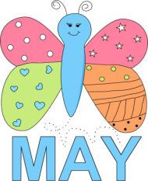We have been very busy in class getting ready for the “Celebration of Learning” on May 12th, 6:00 – 7:30 p.m.

Today, you will find a pink memo from the office about this fabulous night in your child’s backpack. **\*\*Please, consider donating items to the raffle baskets for your child’s grade level☺**

Dates to remember:

Tuesday, May 3rd

2nd Grade Music Program

2:30 and 7 p.m.

May 5th and May 6th

NWEA/MAP testing

Thursday, May 12th

Learning Celebration

Tuesday, May 24th

1st grade music program

2:30 only!

**Curriculum Connection:**

In **math**, 2nd grade practiced estimating and finding exact cost of items. They learned how to make change. They explored the area of their feet and hands and made geoboard fractions. The students are also learning about place value and the value of each digit in numbers.

Coming up in Unit 11; beginning May 9th. They will review finding estimates for sums of money, calculating values of coin and bill combinations in number stories. They will also review making change by counting up, and solve comparison number stories with money. The students will also practice the trade-first subtraction algorithm.

**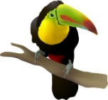**

**In Science, first graders have been researching how animals move, what their body coverings are, and what distinguishes them from the different animal groups. We have partners that are the “experts” for each animal group.**

**Thank you for your support on helping the students research an animal of their choice. This information will be put into a slide show presentation here at school. In addition, they have made an animal for each animal group, we just have the reptile left to make☺**

**pe03254_**

**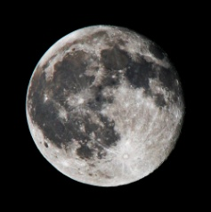Second graders had a wonderful experience at Geer School! They have learned a great deal about schools long ago and life long ago!**

**They will begin a Space Unit next!**

C:\Documents and Settings\Watson Family\Local Settings\Temporary Internet Files\Content.IE5\LE9CN8DP\MC900440424[1].wmfIn **guided reading**, both grades have enjoyed a few traditional tales and narrative fiction stories.

While reading we have focused on making conclusions (inferring), sequencing events, cause and effect, visualizing and summarizing the stories. We are having excellent ***conversations*** about the stories!

Next week’s, 2nd grade Journey’s story is *The Goat in the Rug* a narrative fiction story. Our focus will be “How is art connected to the past?” They will practice sequencing of events and making conclusions (inferring) with this text.

First graders, enjoyed reading the classic story by Ezra Jack Keats, Whistle for Willie. They made great connections and found cause and effect examples throughout the text.

Next week, they will read an informational text; *A Tree is a Plant*. They will work on sequencing the events.

In writer’s workshop, the first graders have worked diligently on creating two “All About” stories. They picked a subject that they knew a lot about (soccer, seasons, *me*, etc.) and wrote information and facts about it.

Second graders have put forth a great deal of effort researching their rain forest animals. They are working on writing the final copies of their reports! They will also create their animals to hang up for the learning celebration.