Mrs. Watson’s Class News
October 11, 2015
Edition 2
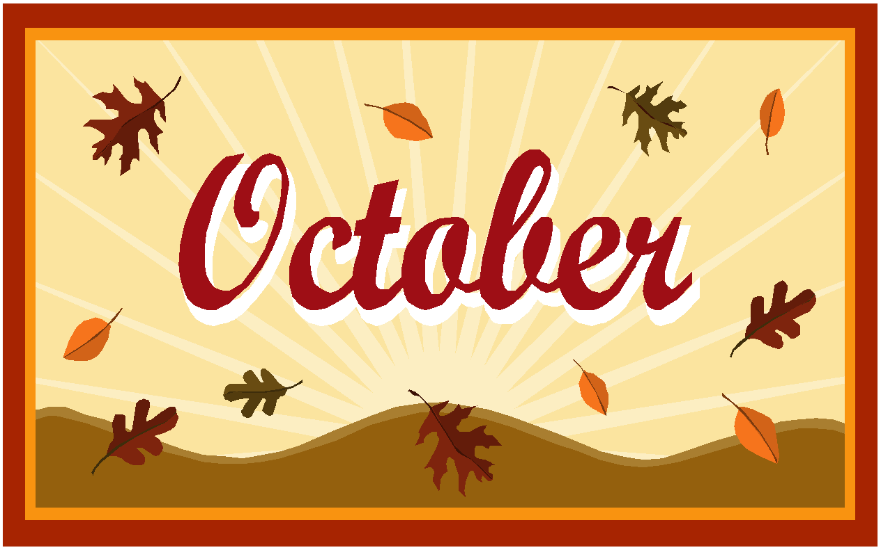
The month of October is well under way! We have been talking about the season Autumn (aka Fall) and are doing lots of fun activities to celebrate it.

Our first classroom party will be held on Friday, October 30th.
We are asking each student for a donation of $10.00 to cover ALL 3 parties that we will have this year. This allows those who plan the parties to be reimbursed for their expenses for picking up supplies. This system has worked quite well in the past.
If you have not yet done so, please send in the $10.00 when possible.
Thank you!!

NOTE: Small Change: When you read the newsletter the 2nd grade information will be in red font and the first grade will be blue font. Black font is information for both grades. (Hopefully a little easier to read:)

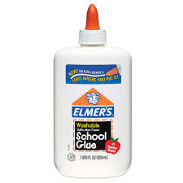
REQUEST
For the Halloween party please send in 1 (4oz) bottle of Elmer’s glue.

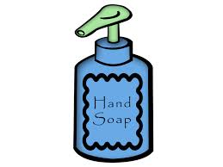
Also, we would really appreciate a donation of hand soap for our classroom. The student’s have a challenging time reaching the one on the wall.

Curriculum Connection:
In Math, we wrote addition number stories, reviewed
“easy” addition facts, practiced our doubles facts and turn-around facts, learned addition strategies, and studied fact families. In addition, we have learned that subtraction number stories are either Change-to-less or a comparison.
We will be exploring weights, scales and equal groups.

In Science, second graders are finishing up their study of plants! Their bean plants really grew! I hope you are enjoying them at home.
First graders, are learning about insects. They learned about the 3 body parts (head, thorax, abdomen), that they have 6 legs, and how they camouflage for protection. We went on an insect hunt and found a few in the grass. They made an insect out of marshmallows and they will paint them this week. They were excited to hear about the insect project that they will create at home. Thank you for your support with this!

In Social Studies, first grade created a bird’s eye view of our classroom and we went on a scavenger hunt throughout Dodson looking at and following a map of the school. They collected a puzzle piece in different areas to connect to make our one school community! We will be taking a walk on the playground and creating a map of that as well.

In Writer’s Workshop, all the student’s wrote a true Narrative “Fall” story. This week they completed the prewriting stages, using a flow chart to put their events in sequence. We discussed the importance of having a strong lead and learned about the many ways that author’s begin their stories to excite the reader.
Second graders will begin research on spiders this week.

In Grammar, we looked at the hard and soft sounds of “G” and the sounds for the letter “C”. We have practiced the long and short vowel sounds and discussed the patterns. Next week they will study consonant blends with r, l and s.
They have also learned the difference between a sentence that is a statement, question or exclamation.
First grade, reviewed nouns and possessive nouns. They also looked at actions verbs. They have an interactive language arts notebook that a lot of their daily work goes into. This week they will study adjectives using Poprock candy to add descriptive words!
Both grade levels were taught how to use context clues to determine the meaning of a word with multiple meanings.
In addition, they are writing sentences every week, focusing on the phonics/spelling words of the week. These are dictated (read) to them and this is kept in their writer’s binders.

In Guided Reading, we have discussed the author’s purpose for writing, PIE (Persuade, Inform, Entertain). The students analyze text, thinking about details as we read. Last week we found the cause and effects in our reading of the Dairy of a Spider. They continue to practice their fluency and accuracy while reading; recognizing the high frequency words and vocabulary words. Friday, they wrote our own diary entries for Spider and made a spider for our bulletin board. The students will also learn how to read non-fiction texts to help increase their comprehension of informational texts. They are learning how to use the text features (table of contents, bold words, glossary & index) to help them make meaning of the text.
First graders, read Curious George at School and a short informational text about schools long ago. We worked together to sequence the events of Curious George. We also had a conversation about the author’s word choices and how they help the reader to visualize. This week they will read an informational text Lucia’s Neighborhood and discuss the text and graphic features. We also continue to work on fluency and accuracy while reading; recognizing the words to know from their weekly list.
All the students are learning how to respond to reading and write a short paragraph every Tuesday giving their opinions.
The Book-It program started at the beginning of this month. Those students who wish to participate will receive a Pizza Hut coupon after turning in their reading log calendar at the end of the month.

