Mrs. Watson’s Class News
November 13, 2015
Edition 4

I would like to thank Mr. and Mrs. Kenski (and Grandma), Mrs. Ramanathan (and Grandma), Mrs. Freeman, Mrs. Lone, Mrs. Zhou, and Mrs. Sastry for helping plan and organize a wonderful Halloween party!
Our next classroom party will be on Thursday, December 17th.
Check out the photos!

I can certainly say at this time of year that I am thankful for the opportunity to be your children’s teacher. They are all truly amazing kids and I feel fortunate to be a part of their lives. There will be no school on Wednesday, Thursday and Friday Nov. 25, 26th and 27th! I hope everyone has a wonderful, relaxing time off.

Thank you for signing up for December conferences. I am looking forward to sharing your child’s progress with you and your child. The students will have half-day dismissals on December 9th and 10th.

Curriculum Connection:
In math, second grade is currently working on unit 4. The students have practiced with change-to-more number stories, discussed and solved number stories about temperature changes and they have explored temperature, money and shapes.
Next, they will learn how to use estimation, develop strategies for adding 2-digit numbers mentally, and make change for whole-dollar amounts up to $1.00. In addition, they will explore length and area, develop paper-and-pencil strategies for adding 2 and 3 digit numbers. Finally, they will be introduced to the partial-sums addition algorithm.

In Writer’s Workshop, second graders are learning how to write an informative paragraph. This week we practiced putting facts and definitions into their own words. This is a challenging skill for most! We have discussed how to include a variety of word choices and the importance of organizing our writing. They wrote a weather cinquain poem, using descriptive word choices and painted a picture of the weather.
Next week they will write an instructional paragraph.
First graders, have been practicing their handwriting skills, fixing scrambled sentences, and adding punctuation and capitalization.
They wrote an animal cinquain this week and painted a picture of their animal. They used adjectives and verbs to describe an animal. Their focus next week continues to be informative writing. They will be writing thank-you notes.

In grammar, we discussed and practiced proper nouns, verbs, plural nouns, and homophones. In addition we studied various words with double consonants and digraphs (th, sh, wh, ch and tch). The student’s will also practice adding endings to base words (s, -ed, -ing).
First graders, have focused on putting commas in a series of words and using a glossary. They continue to review nouns, verbs, and adjectives.

Self-selected reading (SSR) continues to be a favorite time of day for the students. Ask your student what they have been reading during SSR and what they have enjoyed about the books.

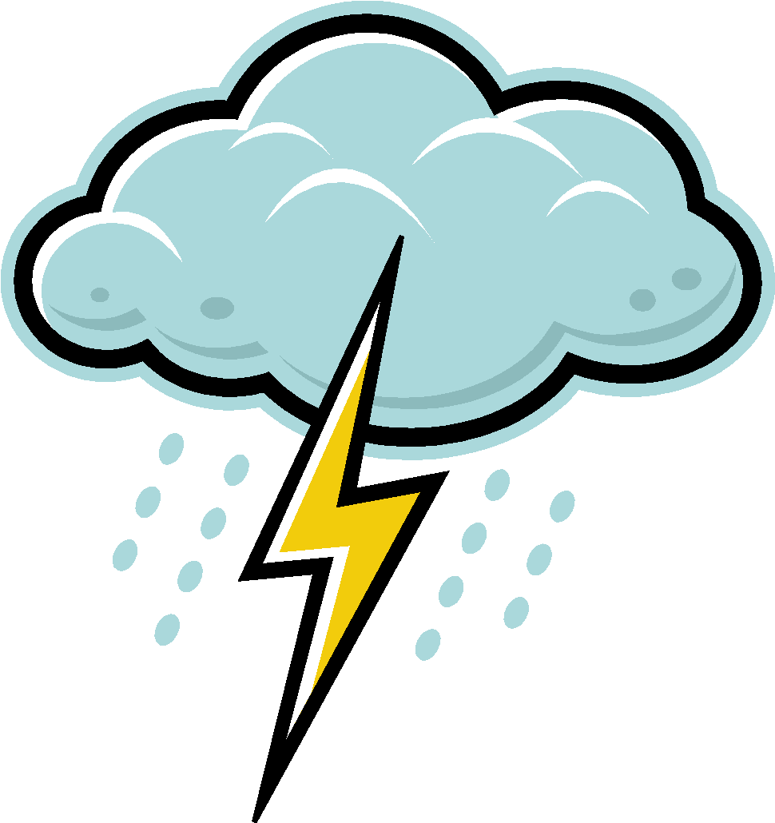
In Guided Reading, second grade read The Ugly Vegetables last week and focused on story structure and making conclusions (inferring).
read about storms and discussed the main idea and the supporting details that the author included in his story Super Storms. We also enjoyed a few weather poems.
We had some great conversations about storms!

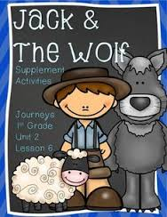
First grade, enjoyed reading Jack and the Wolf last week. We discussed how this story was a fable and that a character normally learns a lesson (moral of the story). Jack learned not to “cry wolf”.
We focused on Jack’s characteristics and how he changed during the story.
This week we have enjoyed reading How Animals Communicate. They focused on text and graphic features (headings, pictures, captions) to understand this informational text. We also discussed the main idea and found the supporting details in the text. We learned how animals use their senses to communicate. Ask your child what a dog does to show he wants to play (see).

In Social Studies, first grade has started a new unit of study: “What is your story?”. I hope you enjoy the homework assignment of interviewing a parent and grandparent. They will be learning about generations, how there are many different kinds of families, and they will be creating a timeline and family tree with the photos you send in.

Have a Happy Thanksgiving!!

