Mrs. Watson’s Class News
January 22, 2016
Edition 7

The cold temperatures have kept us in a few days this week during recess! I am glad it is beginning to warm up! Keep sending in the warm winter gear, in case we do go outside. It is also a good idea to label their belongings!

We will be celebrating Valentine’s Day, “A Sweet Day of Friendship at Dodson” on Friday, February 12th from 10:45 - 11:45 a.m. Students may bring in a Valentine for their classmates on this day. I have included a class list below. They must also bring in a decorated box for their Valentines. See Below!
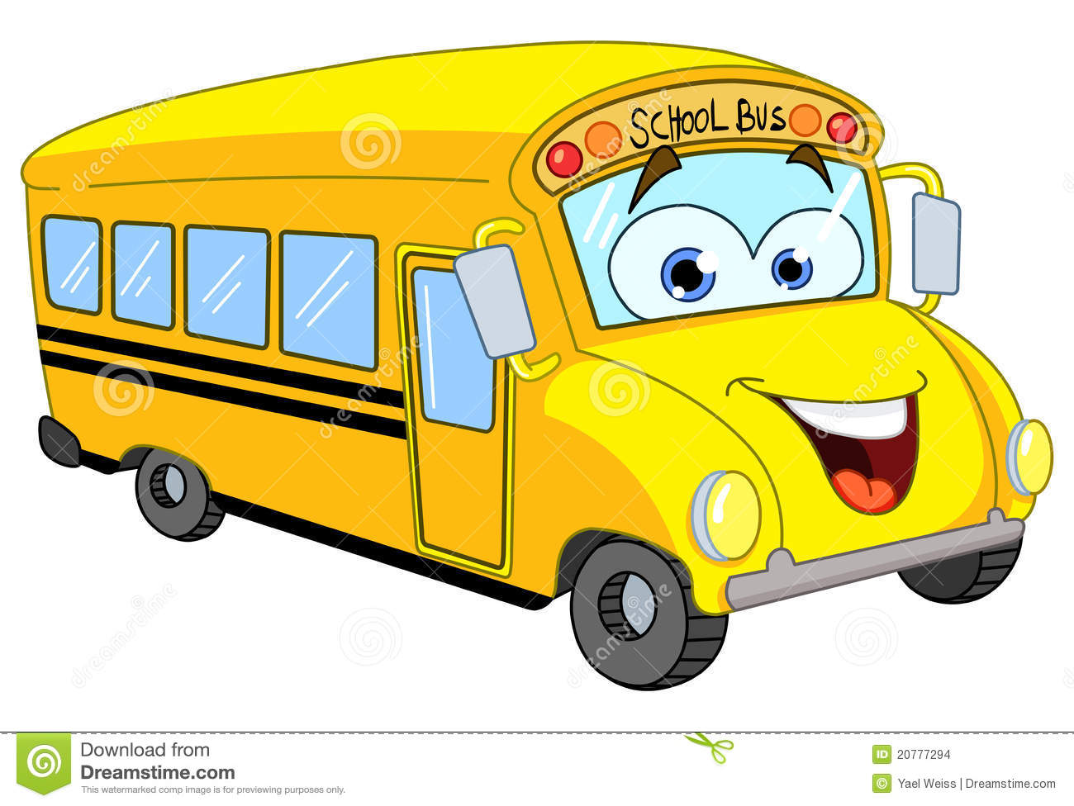
Please, remember to send in the field trip permission slip by Monday, Jan. 25th!

NO School on Friday, January 29th!

Curriculum Connection:
In math, second grade will complete Unit 6 next week. The students worked with multiplication-array number stories and division stories using equal sharing and making groups of items.
We will start unit 7 next week. Students will review counting by 2s, 5s, and 10s and describe patterns they notice. They are building their mental math skills for adding 3 or more 1 and 2-digit numbers. They will practice doubling and halving numbers. They will explore weights, equal sharing and patterns.
Students should be practicing their subtraction and addition facts at home! If you would like blank copies of the mad-minutes for practice let me know.

In Writer’s Workshop, second graders wrote a persuasive paragraph about going on a class trip. They will be writing a persuasive essay in the coming weeks about a hero in their life. Persuasive writing begins with a with a topic sentence stating their goal and reasons with facts and examples to persuade their readers. The goal is to continue to add details and organize the beginning, middle and endings.
In first grade, we read the story Snowmen at Night, and they brainstorm ideas about what their snowman would do at night. The focus was to begin with a topic sentence and add details to enhance the beginning, middle, and ending to their story. They are beginning to check their writing for correct punctuation and capitalization. This week they also wrote a short paragraph about their favorite season and another short paragraph describing how the seasons change.
All the students are writing How To Build a Snowman. The focus is to use time-order words (first, next, then, last) and include details. This how-to writing will be part of a snowman they create out of construction paper.
The “If I Were A Snowflake” paragraphs turned out wonderful! These are now displayed on our bulletin board. They really enjoyed making a paper snowflake with this writing.

In Guided Reading, second grade enjoyed reading a biography about Helen Keller and learning about her life. They have used their I-pads to due web research on Helen Keller and the Schools Long Ago story from last week.
The next Journey’s story we will be reading is Officer Buckle and Gloria focusing on Cause and Effect. We will also be discussing why it is important to follow safety rules.
We also continue to discuss and use comprehension strategies to strengthen their reading skills during both guided reading and SSR.
First graders, enjoyed reading the folktale How Leopard Got His Spots and sequencing the events. We talked about the story lesson as well. This past week we read Seasons. They practiced the skill of identifying the cause and effects throughout the story (Cause: Plant seeds in the Spring --- Effect: flowers will grow). Their next Journey story is the Big Race a fantasy story with a focus on why it is important to have rules.

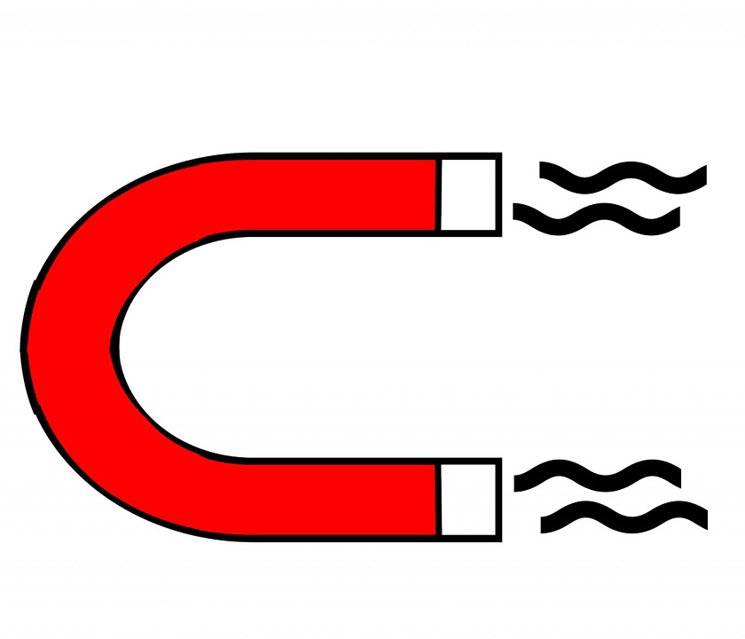
In science, first graders have enjoyed experimenting with magnets and learning that similar poles repel and opposite poles attract. They investigated what objects magnets can or cannot attract through (water, wood, foil, hand, shoes, etc.) Essentially the thickness of material matters. We will complete this unit next week.
Second graders, have been enjoying the various experiments with matter. They will be taking the matter assessment the first week of February.

In grammar, second grade have reviewed proper nouns, the suffix -ly, using quotations marks in dialogue, and practiced using a dictionary.
First grade has learned about the subject and verb agreement, proper nouns, digraphs, and adding -ed, -ing and -s to base words.

NOTE: The students have had an opportunity to use their I-pads to go to Vocabulary/Spelling City to practice their current spelling words. I am updating the lists.
They enjoyed this website!!
Check it out!!!
https://www.spellingcity.com/noreenwatson1/

See the next page for Valentine’s Information!

Valentine’s Day is February 14th! Our celebration “A sweet day of friendships at Dodson” will be on Friday, Feb. 12th!
Students will need to bring in a decorated box for their valentines. Please, do NOT send them until the week of Feb. 8th. I wanted to give everyone enough time to find a box (cereal box, shoe box, etc) and decorate it for Valentine’s. Be sure to cut a hole in the box big enough to put cards and other small treats in and put their name on it large enough for all to see.
We will be enjoying ice cream sundaes! Please, again let me know if you have any restrictions on snacks.

Please remember to give one valentine to each classmate☺
23 Students

Students can bring in their Valentine’s and boxes the week of February 8th.

Colton Freeman Jaden Ding
Muhammad Hamdan Eduardo Hernandez-Alor
Paul Jouraij Skyler Kenski
Muaad Lone Vedanth Kondur
Usman Quraishi Lauren Meyers
Zenya Ramanathan Sam Nieset
Naya Smith Erin Owens
Luke Vartanoff Liam Reynolds
Lyla Wiacek Shae Young
Tristan Zoarob Anthony Baruk
Jimmy Ackron Naomi Czapiga
Rachel Aeck

