**Mrs. Watson’s Class News**

**April 15, 2016**

**Edition 12**

**MC900232180[1]**

**I think Spring has finally sprung! Hard to believe there are only 9 more weeks left of this school year! Lots of wonderful things are happening in our classroom!**

**pe03254_Coming up – Second Grade**

**– Geer School**

Second graders will be going on their field trip back in time to the 1880’s, visiting Geer School. Students should try to come dressed as a student from the 1880s and bring a lunch appropriate for that time period (no lunchables☺). There will be water available at the school.

Dates to Remember:

**Tuesday, May 3rd**

2:30 and 7:00 p.m.

2nd grade music program

**Thursday, May 12th**

Dodson Learning Fair

**Tuesday, May 24th**

1st grade music program

2:30 p.m. only!

**Friday, June 3rd**

Zoo field trip

**Curriculum Connection**

MC900290682[1]In **math,** second graders will begin unit 10 next week. In this unit they will be working on decimal notation, specifically its use in the dollar & cents format. In addition, they will explore how to enter money amounts into a calculator and interpret calculator displays. We will also discuss and practice the use of estimating when shopping and how adding by 10’s can be a great tool to do this. We will also begin exploring place value concepts and use various tools (base-10 blocks, etc.) to provide more experience. Students should continue to practice their addition and subtraction facts!!

**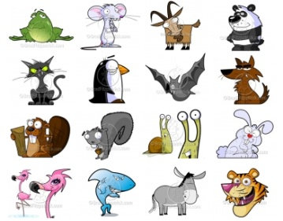In Science, first graders are beginning their unit study on animals. We started with defining “what is an animal?” This week we have focused on five groups of animals: mammals, birds, fish, reptiles, and amphibians. Ask them what group they will become an expert on! They will be able to identify the basic needs of animals, learn that animals use food as a source of energy to grown, compare life cycles, and recognize that animals share many, but not all, characteristics of their parents.** **Finally they will be choosing an animal to do a research report on☺**

MCj04281130000[1]In Guided Reading, second graders read the informational text *Penguin Chick*. They discussed the main idea of a few pages and provided details to support the main idea. Next week’s story is, *Gloria Who Might Be My New Best Friend* , the focus is “How do friends help each other?” They will be able to compare and contrast the two main characters of this text and at the same time make connections to their friendships. We will discuss how character’s change throughout a story. The informational text will be *How to Make a Kite.*  They will make a windsock to hang in our room for a while.

 First graders enjoyed reading *Frog and Toad, The Garden*. We discussed the story structure and the character traits of both Frog and Toad. They made Frog and Toad on construction paper and wrote the character traits on these. They are hanging up in our classroom. Next week, they will be reading the informational text *Amazing Animals.* This is a perfect addition to our study on animals! The reading focus is making conclusions.

 **In writer’s workshop, both grade levels wrote a color simile poem and they typed them in the computer lab! These are displayed in our hallway.**

**Second graders have started their research report on a rainforest animal. They are using multiple resources to research various topics on their animal. This will be an exciting and challenging project for them! They are learning how to find information and put that information into their own words.**

**First graders just completed an opinion story. They started with a topic sentence, provided 3 reasons with examples and a concluding sentence restating their opinion. They will begin researching an animal from their animal group this weekend! Information is coming home today (Friday) regarding this project! They are very excited to be doing a research project too!**

Grammar/Spelling:

Second Graders are reviewing adjectives. Next week’s spelling words are homophones.

First graders practiced using pronouns “they” and “we”. Next week, they will use the pronouns “I” and “me”.

\*\*Updated lists are on spellingcity.com

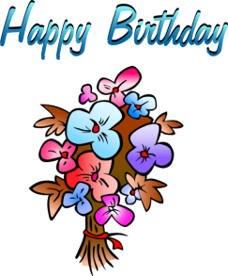

Vedanth Kondur – April 11th

Naya smith – April 12th

Nay Naya Nay