Mrs. Watson’s Class News
December 4, 2015
Edition 5

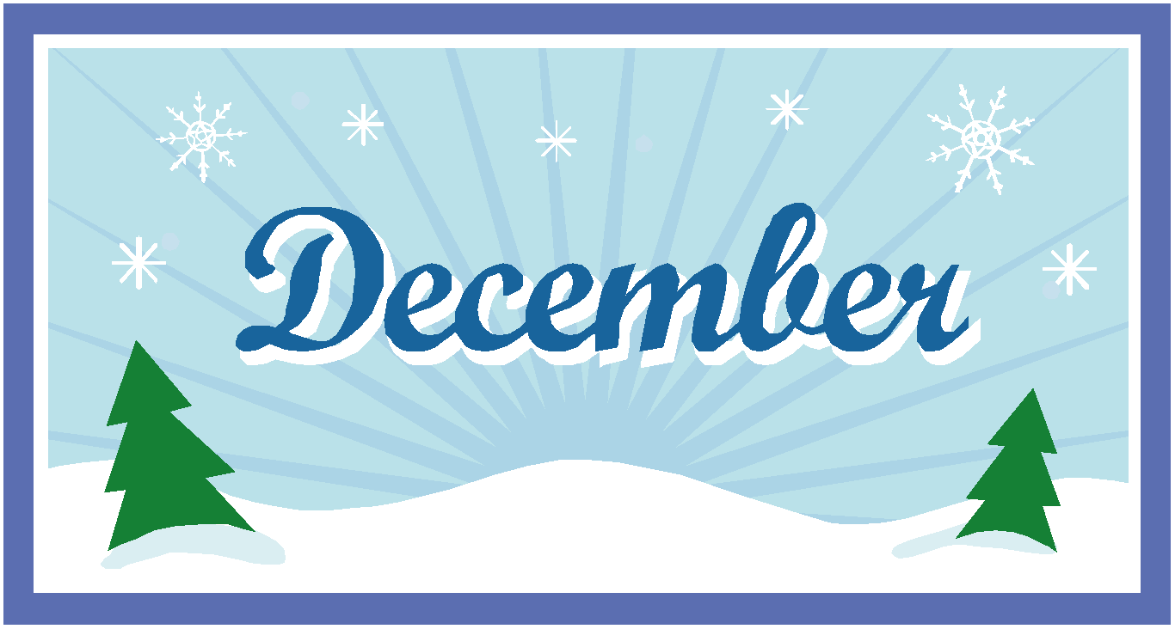
Hard to believe only two short weeks until our holiday break! Conferences are next week! You should have received a reminder slip from me at the beginning of the week. Please, let me know if you need to reschedule your time! Remember the students will be attending their conference with you. If you would like to meet with me separately as well, let me know.

**Dodson Student council is collecting new, unwrapped toys as part of a school wide community service project.
Starting Monday, the 7th, the student council will be selling candy canes to students to send to a friend or sibling at the school. They are 25 cents each and they will include a message. These can be bought during their lunch.

Students will be able to shop at the Holiday Shop on Tuesday, Dec. 15th at 1:00.

Our holiday party will be on Thursday, December 17th from 1:00- 2:15.

Please, be sure to let me know if your child has any snack restrictions.
I am aware of a few peanut allergies. So please check below:
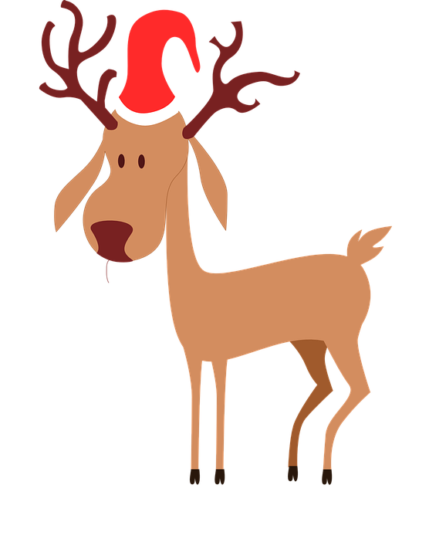
Next week, the students will be enjoying some activities to go along with a small reindeer day celebration we are having next Friday, the 11th. Some of the food items we will be using are marshmallows, graham crackers, chocolate chips, pretzels, and red m&ms.

Also, we were planning to decorate sugar cookies at the holiday party on the 17th. If there is an alternate product I can get for any student, please let me know!

On Friday, December 18th, Dodson is having a school-wide Polar Express Day! Be sure to check out this information on the latest Dodson school news. Students can wear their pajamas on this day, but they do not have to.

As you can see there are a lot of wonderful things happening the next few weeks!

Curriculum Connection:
In Math, 2nd grade students have had timed mad-minute addition facts tests. Next week we will have the first subtraction mad-minute. Throughout the year they will work on mastering their basic facts completing 50 problems in 3 minutes or less.
We will begin unit 5 next week, the students will explore polygons, attribute shapes, arrays and learn beginning concepts of division (sharing equally). In addition, they will learn about points, line segments, parallel lines and quadrangles.
We will complete this unit studying 3-dimensional shapes, pyramids, and line symmetry.

In Social Studies, first graders are continuing their study of families. Thank you for helping them with their interview questions and family tree. They made their family trees and these are hanging in our hallway. We have been spending time reading about how there are many different kinds of families. We are also discussing and looking at photos from long, long, ago, and present time of toys, clothing, and appliances. They have enjoyed writing about the toys that their parents and grandparents played with!

Science: Second graders have started a new unit on Matter. They will learn that matter takes up space and has mass. They will investigate solids and discuss the properties of various solid objects. They will be engineers building a tall tower with the solid objects, taking into consideration the properties of the objects. This unit is a lot of hands-on fun!

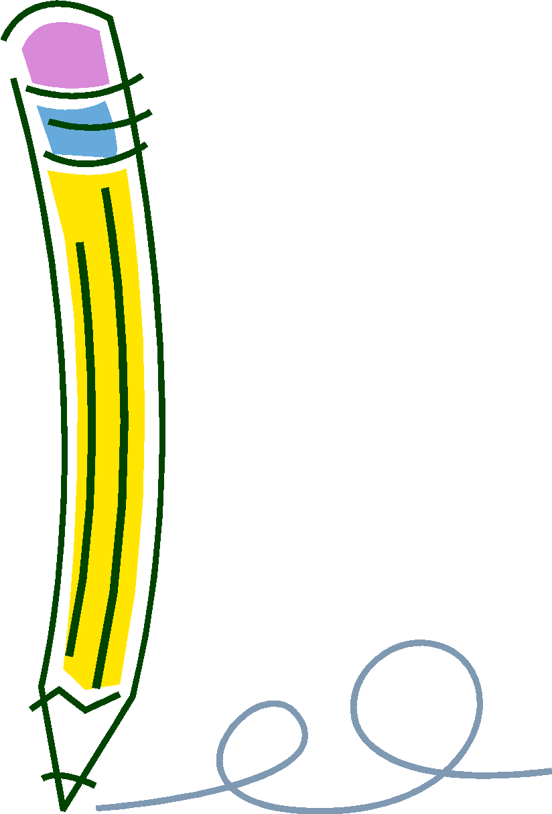
In Writer’s Workshop, both grade levels wrote a How-to paper; writing step-by-step instructions of something they have done. They started by identifying characteristics of a good informative writing piece. Such as, using time-order words, stating in the beginning the topic and in the adding a concluding sentence.
This week both grade levels wrote a poem about their favorite place. The used their five senses to describe the place, “Come with me and see…”. These poems are displayed in our hallway.
Next week, second graders will begin looking at and writing opinion stories and persuasive letters.

In Grammar, 2nd graders learned and practiced using verbs in past, present and future tenses. They have also practiced adding suffixes to base words, such as, -ed, -ing, -er and –est.
This week they studied contractions and practice using them in various activities.
There are many skills and activities we complete during the week in grammar. Many times they are practicing the skill by putting interactive pages into their language arts notebooks. They will be sharing these at conferences.
This week they practiced and discussed singular and plural nouns and writing antonyms (opposites) for words. They also reviewed short o and short e vowels and created blends with the consonants l and s.

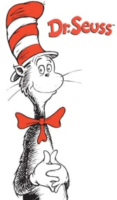
In Guided Reading, first graders read and sequenced the events of the realistic fiction story, A Musical Day.. That week we focused on how music is part of our everyday lives. This week we read a biography of Dr. Seuss! They really enjoyed reading about Dr. Seuss and we enjoyed a few of our favorite Dr. Seuss books. On Thursday, we practiced reading a couple of his poems which had alliteration, a pattern of the same beginning sounds, Pete Pats Pigs! We continue to respond to reading on Tuesday and on Thursday we compare texts. Next week we will be reading a fantasy, A Cupcake Party. Our reading skill is story structure and the strategy is visualizing. The focus question: How can you show a friend that you care about him or her?
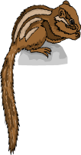
Second graders enjoyed reading the folktale How Chipmunk Got His Stripes. We discussed the genre of traditional tales and how it is a story that is past down generation to generation. We analyzed the characteristics of the chipmunk and bear and used text evidence to describe what kind of character they were like. The students then described their own characteristics☺
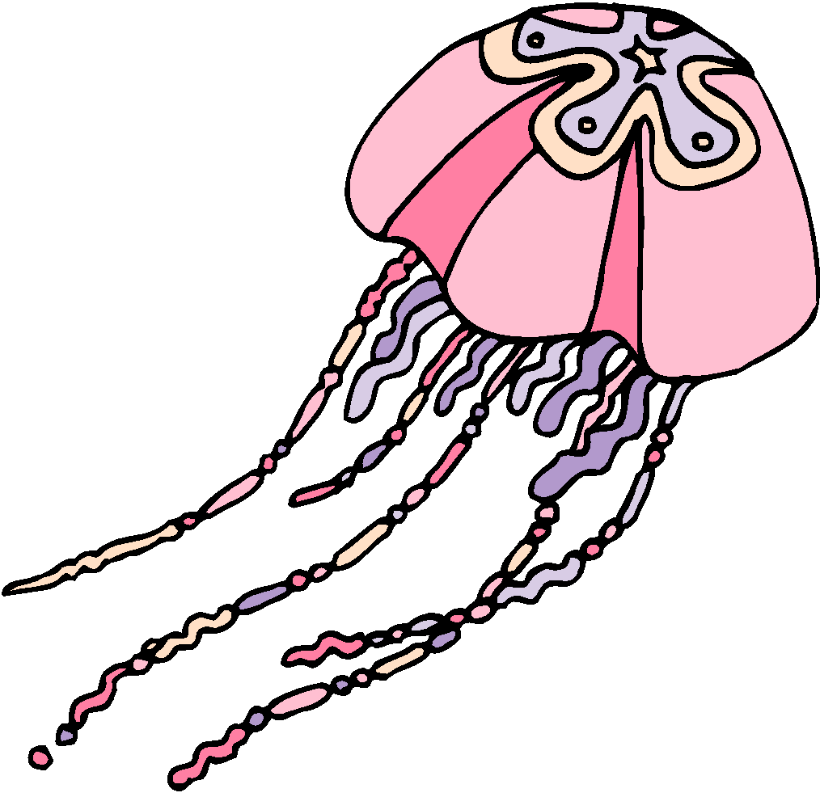
This week they read the text Jellies and learn about jellyfish! We discussed author’s purpose again and determined that the author of Jellies wrote to Inform the readers. We reviewed that informational texts provide facts about a topic. During the week we discussed the facts and opinions that the author included in the text. In addition to Jellies we also read a magazine article Splash Photography and made text-to-text connections between the 2 informational texts.
They made jellyfish today!

In computer lab the students are starting to create documents in their google account and they started a google slide presentation titled, “All About Me”. They will be creating slides that will include a background, theme, clipart, and animation. The best thing about using their google accounts is they have access at home too. Feel free to go to their google and check out what they are working on!
We have also had a lot of fun with Kahoots trivia on our I-pads. They have also been on their RazKids account on the I-pads.

Rachel Aeck - November 30th
Anthony Baruk - December 7th
Lauren Meyers - December 15th

