Mrs. Watson’s Class News
January 8, 2016
Edition 6

Welcome Back! I hope everyone enjoyed their break and spending time with their families.

All students will take a second round of the NWEA MAP testing in math and reading in computer lab. We will complete this testing next week, on Wednesday, Jan. 13th andThursday, Jan. 14th. In addition, all 2nd graders will take a screening test for TAG on Tuesday, Jan. 19th.
Dates to Remember:

Monday, January 18th
No School –MLK Holiday

Friday, January 29th
No School for students

February 13-21
^{No School}
Mid-Winter Break

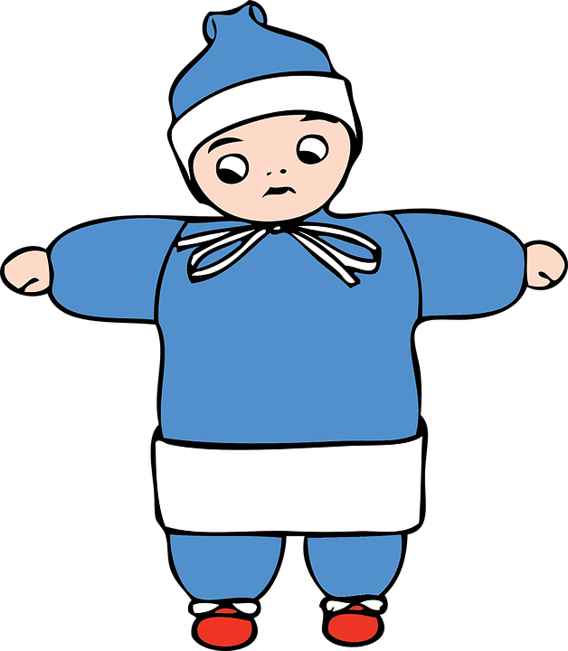
REMINDER: Although, we have had an unseasonably warmer winter, please be sure to check the weather report each day so your child is prepared for outdoor recess.
Boots, snowpants, hat, mittens, etc.

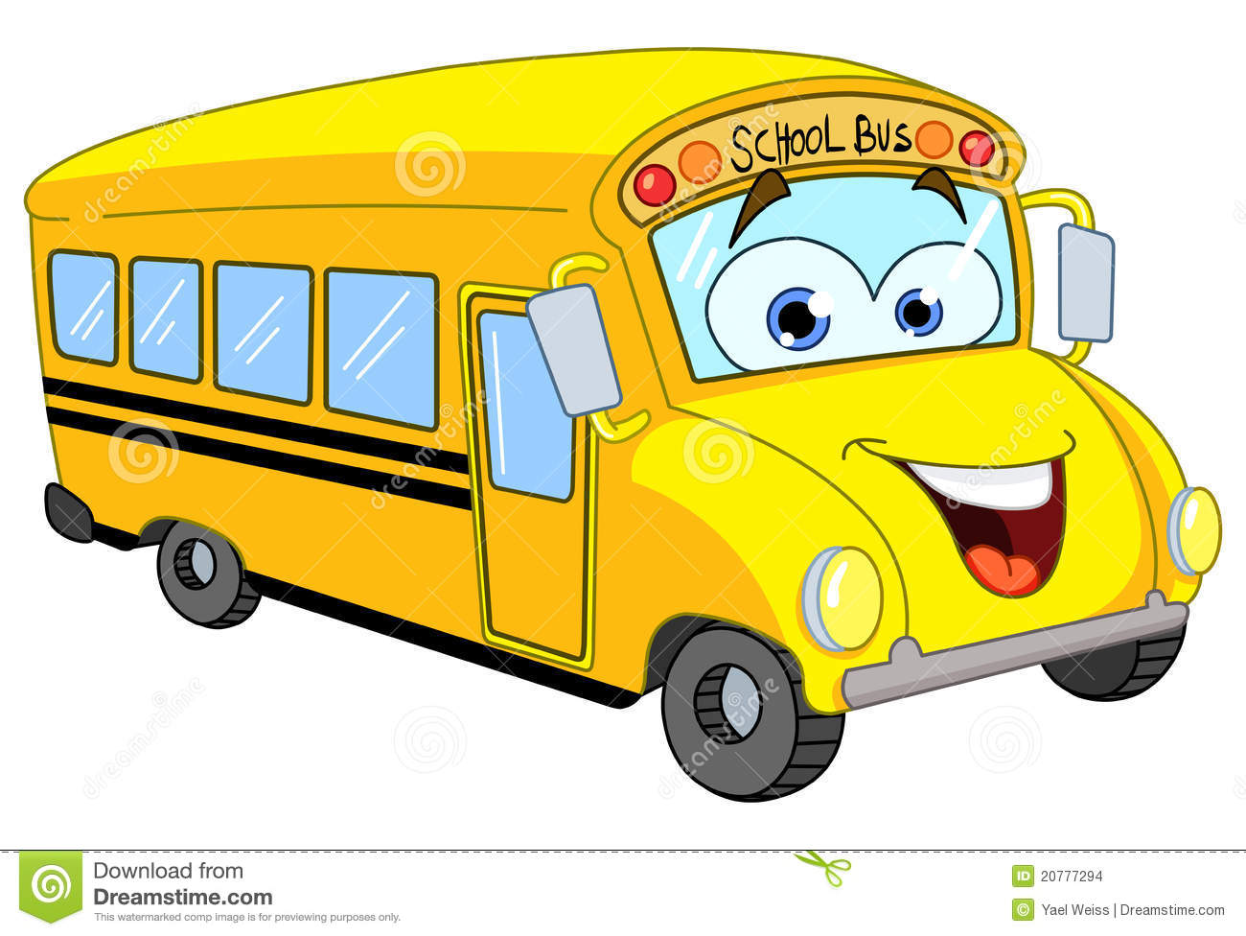
FIELD TRIP: Second grade classes are going to see a play at the Parc Theatre (Central Middle School) in Plymouth, on March, 21st. My first grade students will be joining us!
Look for the green field trip form coming home today.

Curriculum Connection:
In math, we completed Unit 5 before break and started Unit 6 on Monday. The students will review strategies for solving addition problems, with emphasis on problems with 3 addends. They will be introduced to comparison number stories using diagrams. In addition, they will collect, sort, tally and graph data. Students will also practice and review subtraction strategies.
Refer to the Family Letter in your child’s homelink book for further information regarding this unit.
We continue with “mad-minutes”, testing their recall of addition and subtraction facts through 10 + 10. Each student is keeping a graph of their growth. They should be practicing at home or on the online websites found under “kids stuff” on the class webpage. MANY of the students NEED to practice their facts! Especially SUBTRACTION!

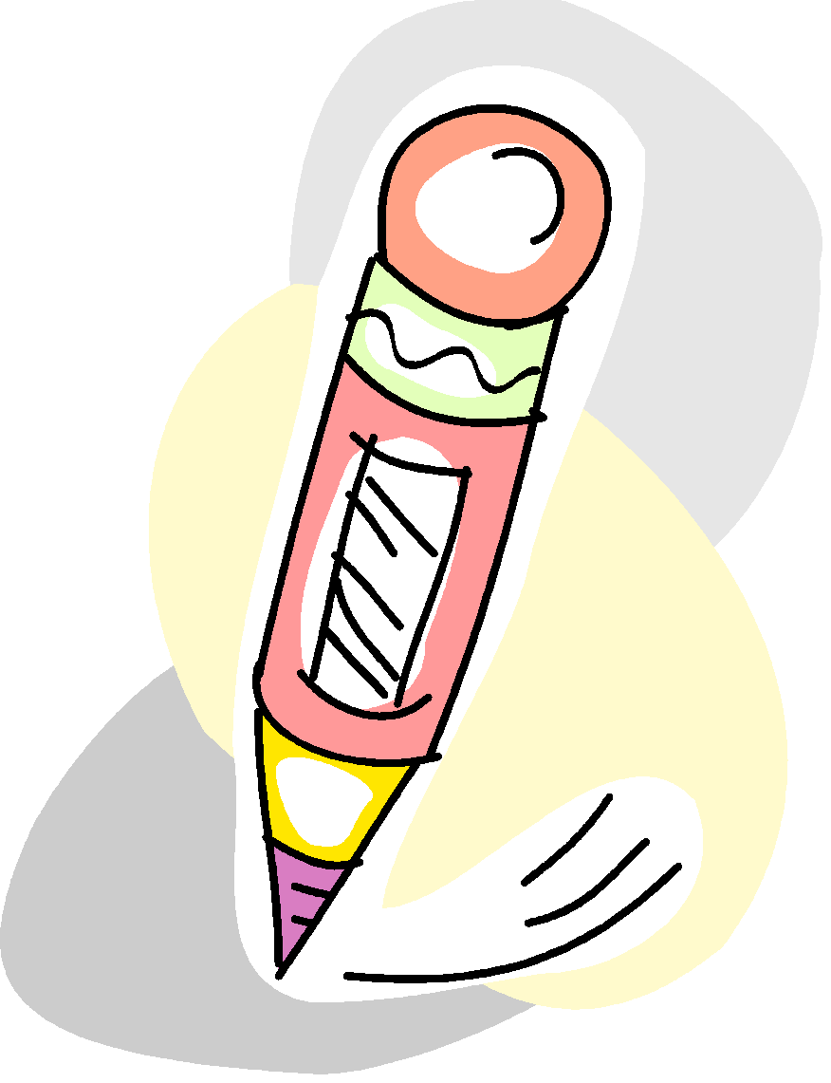
In Writer’s Workshop, both grade levels wrote a New Year’s resolution for 2016! These are displayed on our bulletin board.Also this month, they will write a paragraph, “If I were a snowflake”. They will make and cut out a snowflake to include with their writing.
First graders, wrote about their winter break this week. They began with a snapshot of what they saw, where they went, who they saw, how they had fun, etc. They are beginning to add more details to enhance their writing. Next, week they will work on writing a short small moment story with a focus on a beginning, middle and ending.
Second graders continue to work on persuasive writing pieces. I hope you enjoyed their persuasive letter they brought home this week. They just completed a short opinion paragraph on their favorite kind of music. They were to state their opinion and provide reasons with details and conclude by restating their opinion.
The next few weeks they will be going through the writing process and will write a persuasive essay.

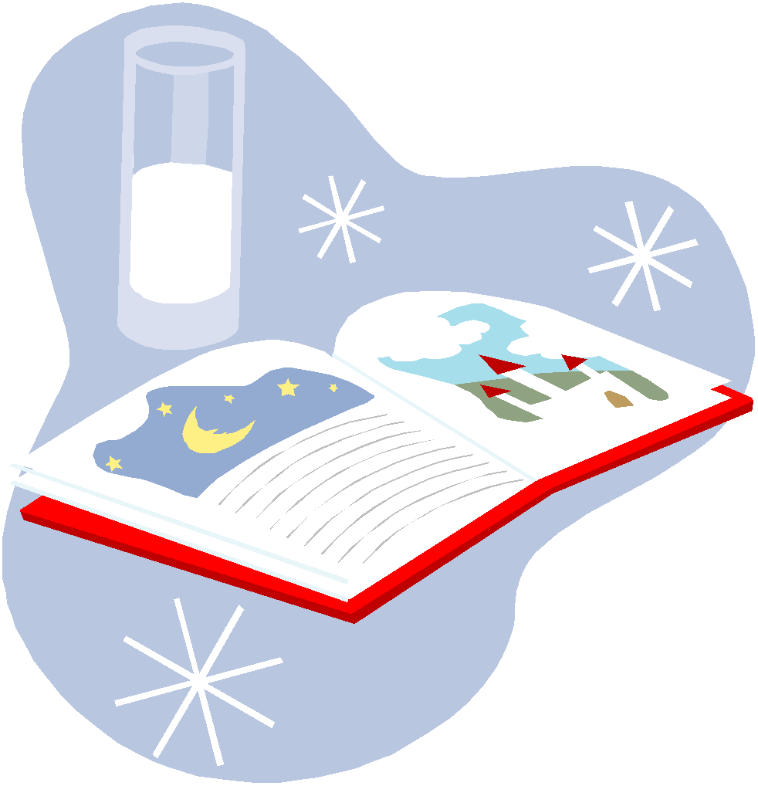
In Guided Reading, second grade read about Music in the anchor text Ahh, Music! They researched an instrument and discussed how music makes us feel. Next week, we will read about Schools Around the World in our Journey’s book, comparing schools around the world. We continue to use strategies to gain a deeper understanding of the text. In addition, we practice fluency and reading with accuracy. The following week, we will be reading about Helen Keller, focusing on the author’s purpose and the genre; biography.

In guided reading, first graders enjoyed reading the informational text At Home in the Ocean. We discussed the author’s purpose; why an author writes a story. P.I.E. Persuade, Inform, Entertain. We had a great conversation about the information in this text. We also read a brief informational text about Water. Next week, they will enjoy reading a folktale, How Leopard Got His Spots. We will discuss how jungle animals are different from animals on a farm. They will sequence the events of the story and discuss the story lesson.

In Working with Words – grammar, second graders have practiced the vowel digraphs of ai, ay, ee, and ea. In addition, they continue to practice recognizing verbs, adjectives, nouns and parts of a sentence. Next week they are using quotation marks and reviewing proper use of capitalization and punctuation.

First graders, have learned what a proper noun is and practiced identifying and stating proper nouns for people, places, things, and animals.
They studied words with the consonant digraph “th” and base words with -es, -s, -ed, and -ing endings. Next week, they will identify and create simple command type sentences. They will also look at the meaning of homophones, words sounding the same, but with a different spelling and meaning.
Their spelling words will have the digraphs, -ch and -tch.
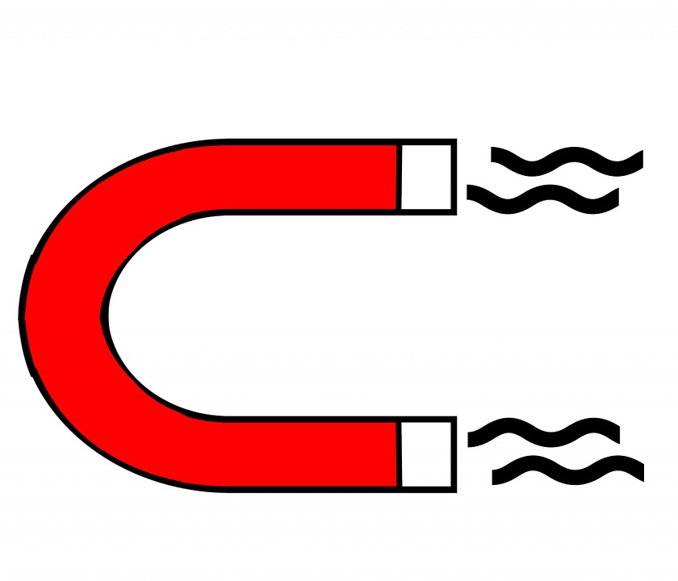
In science, first graders have started their unit on magnets. They are very excited about using magnets and learning what is attracted to them and what is not. Key words: attract, repel, north and south poles.

In SSR, the students continue to enjoy this part of the day and do an excellent job choosing books that they enjoy and are “just right” for them. They look forward to sharing what they have read on their scheduled day of the week. When they share, it is a target skill or strategy we are using in guiding reading!

Tristan Z. - 6th
Sam N. - 21st
Jaden D. - 29th

